**Assignment - GDP- Analysis**

**Project Overview: -**

We are working as the chief data scientist at NITI Aayog, reporting to the CEO. The CEO has initiated a project wherein the NITI Aayog will provide top level recommendations to the Chief minsters of various stated which will help them to prioritise area of development for the respective states. Since different states are in different phrases of development, the recommendations should be specific to states as well.

The overall goal of the project is to help the CMs focus on the areas which will foster economic development for the respective states since the most common measure of economic development is the GDP. You will analyse the GSP of the various states of India and suggest ways to improve it.

**What is GDP ?**

Gross domestic product at the current prices is the GDP at the market value of goods and services produced in a country during a year. In other words, GDP measures the monetary value of final goods and services produced by a country/state in a given period of time.

GDP can be broadly divided into goods and services produced by three sectors: the primary sector (Agriculture), the secondary sector(industry) and the tertiary sector (services).

It is also known as nominal GDP. More technically, (real) GDP takes into account the price change that may have occurred due to inflation. This means that the real GDP is nominal GDP adjusted for inflation. We will use the nominal GDP for this exercise.

Also we had considered the financial year 2015-16 as the base year since most of the data required for this exercise is available for the above period.

**Per Capita GDP and Income**

Total GDP divided by the population gives the per capita GDP (which roughly measures the average value of goods and services produced per person). The per capita income is closely related to per capita GDP (though they are not the same). In general, the per capita income increases where per capita GDP increases and vice-versa. For instance, in the financial year 2015-16, the per capita income of india was Rs 93,293 where the per capita income of India was $1717 which roughly translates to Rs. 1,11,605.

India ranks 11th in the world in terms of total GDP though it lies at the 139th position in the terms of per capita GDP.

**Data Source for the Assignment:**

**The data is sourced from** <https://data.gov.in/>  an Open Government Data(OGD) platform of India. The data for the GDP Analysis of Indian States are divided into two parts:

Data I -A: This dataset contains the GSDP (Gross State Domestic Product) data for the states and union territories.

Data I – B: This dataset contains the distribution of GSDP among the three sectors: the primary sector (agriculture), the secondary sector (industry), and the tertiary sector (services) along with taxes and subsidies. There is separate dataset for each of the states. We are expected to read the dataset for the available states.

**Part 01 – A**

In this part of analysis, we are comparing the average growth of states over the duration 2013-14, 2014-15 and 2015-16 by taking mean of the row (‘% Growth over previous year).

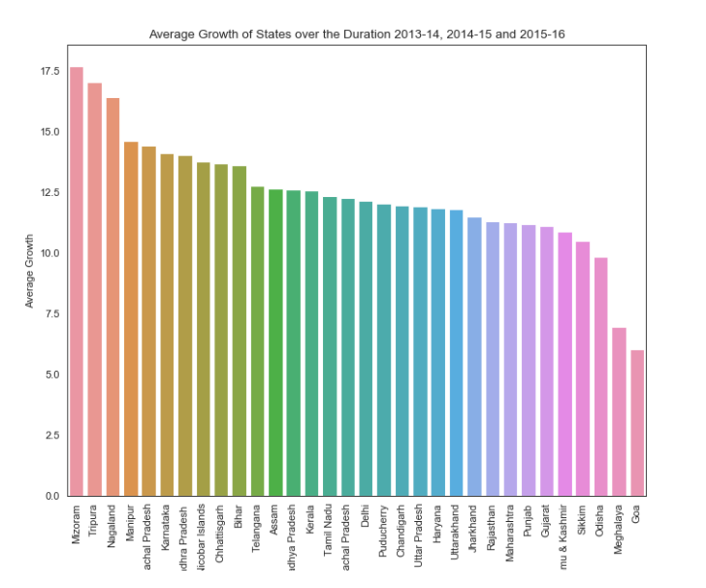

**Fig 01- A**

Below Graph is shown for the individual states and their GDP growth in the last 3 years. Andhra Pradesh, Rajasthan and Meghalaya are only 3 states which has consistently performing well in their GDP.

States like Chhattisgarh, Karnataka, Manipur, Arunachal Pradesh, Mizoram, Nagaland, Odisha, Sikkim, Tamil Nadu, Tripura, Utter Pradesh, Chandigarh and Pondicherry which has consistently struggling in growing their growth. As shown in Fig 01 -B

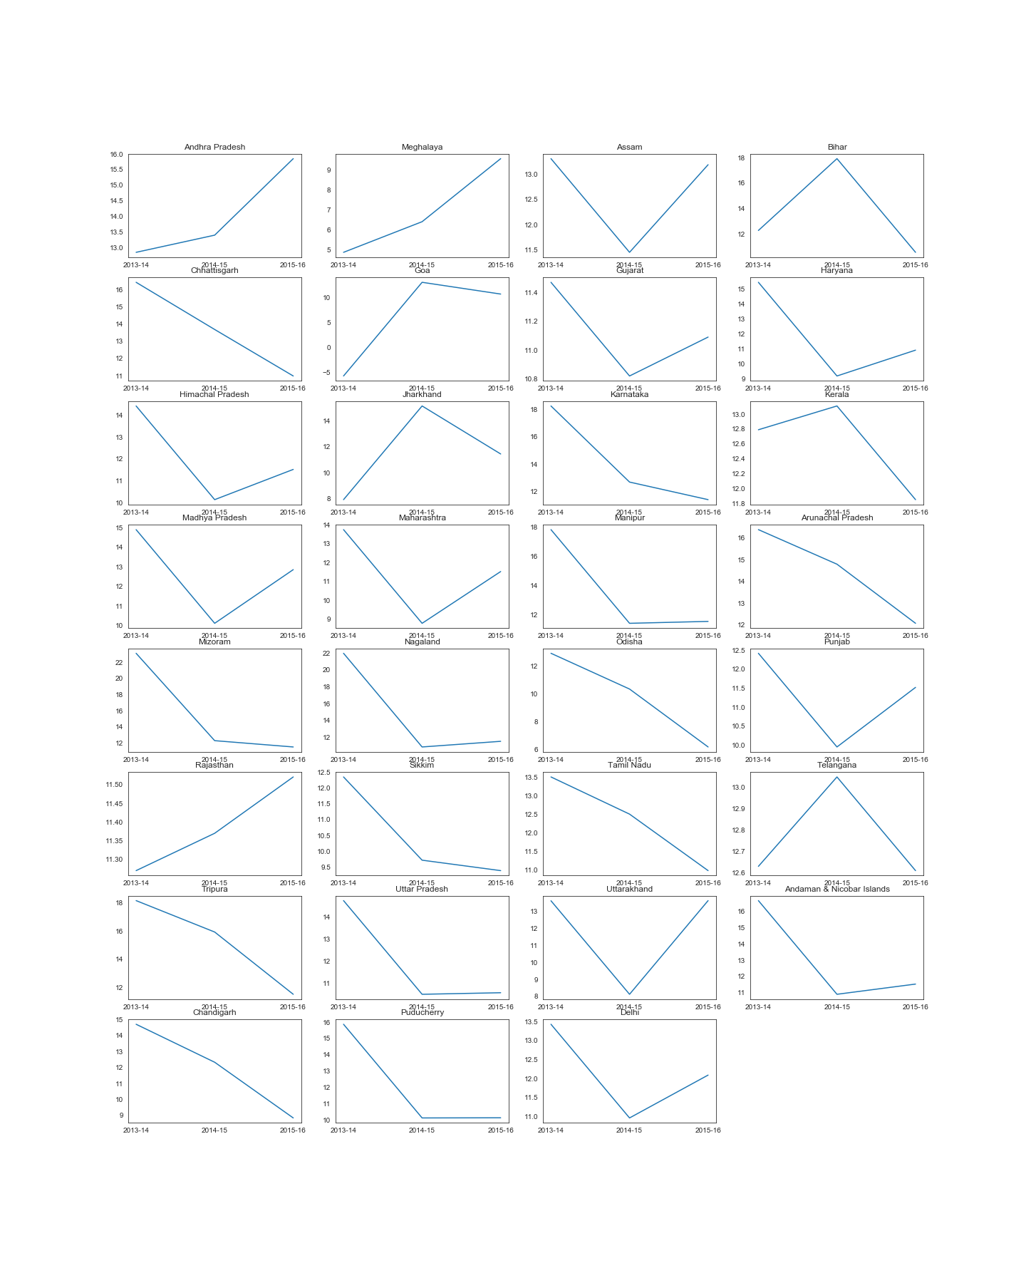

**Fig- 01 – B**

By looking at the below data for duration 2015-16. We can clearly say that Tamil Nadu, Uttar pradesh, Karnataka, Gurjrat has performed very well in the above year.

But states like Sikkim, Arunachal Pradesh, Puducherry, Meghalaya, Chandigarh has not imporved much. As shown in Fig 01 -C.

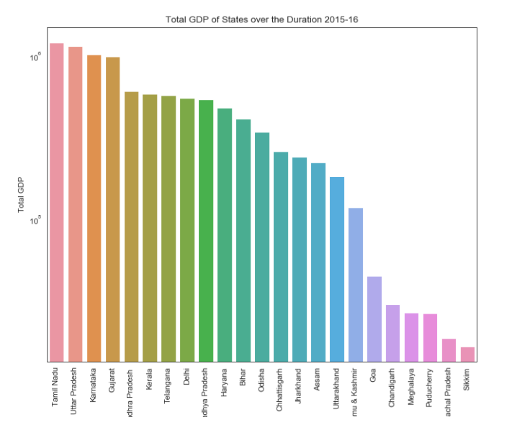

**Fig 01- C**

**Part 01 – B**

In this part we are trying to analysis the GDP per capita of the states and their sectors and subsectors have maximum impact over the GDP per capita.

The below graph shows that different states and their GDP per capita. The Goa and Sikkim has very high gdp per capita as comparison with other Indian states. Other states like Haryana, Kerala, Uttarakhand, Maharashtra, Arunachal Pradesh has almost similar GDP per capita.

But few states like Bihar, Utter Pradesh, Manipur, Assam, Jharkhand have very low GDP per capita between all the Indian states. As shown in Figure Below.

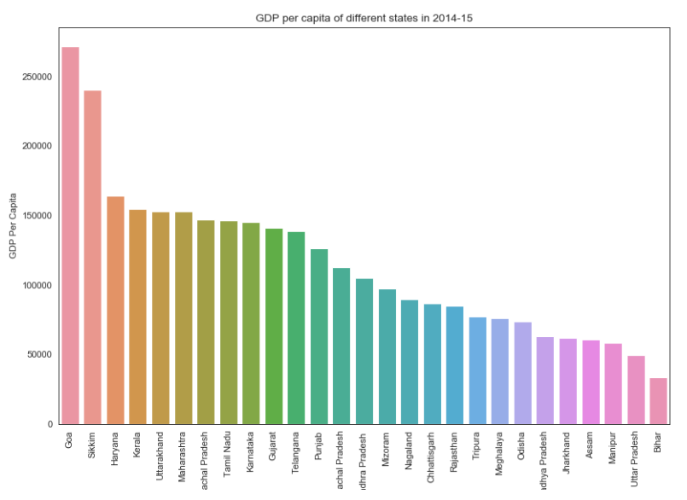

**Fig 01-D**

Looking at the below pie chart we can directly conclude that our most of the GDP is coming from tertiary sector approx. 46% and second topmost is secondary section 25% approx.

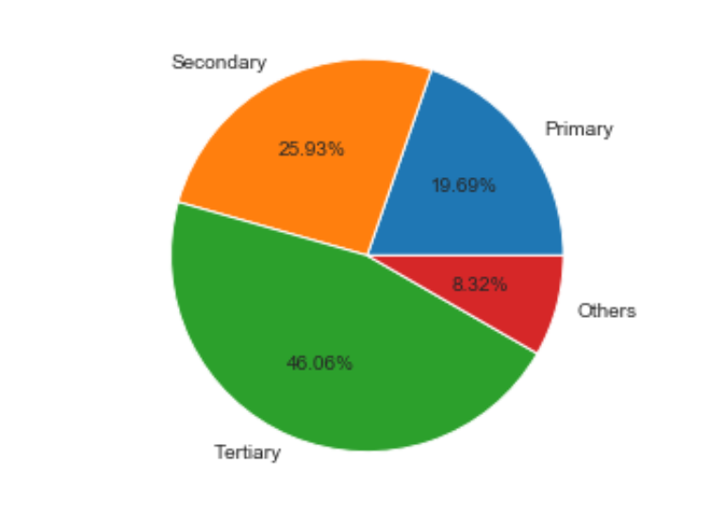

If we deep down on each states and their sectors categorization we can notice that all those states have largest contribution from tertiary sector have high GDP and those have very less contribution in tertiary sectors have very less GDP growth of those states. As fig attached below

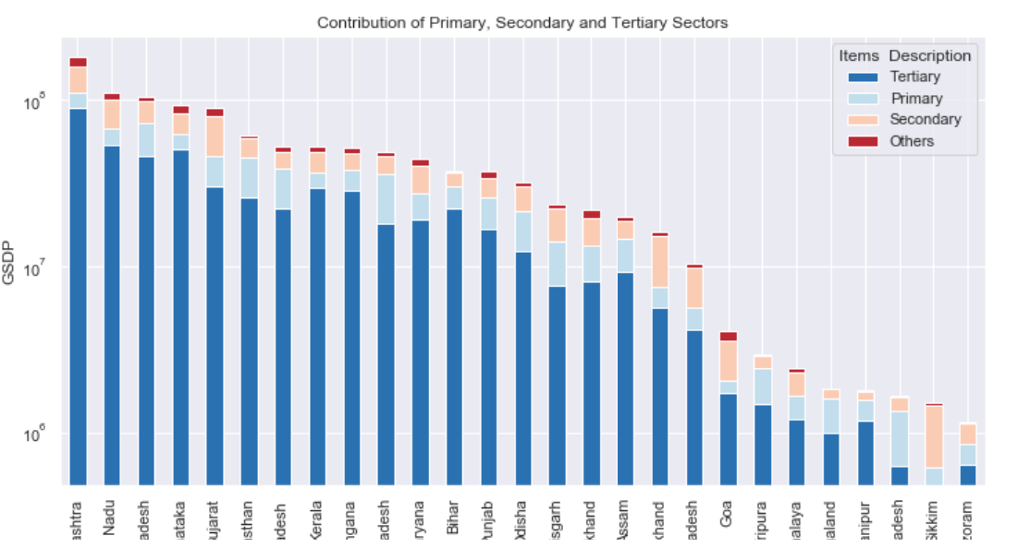

If we categorise the states into 4 categories based on GDP per capita (C1, C2, C3, C4) and C1 would have the highest per capita GDP, C4 the lowest. The quantile values are (0.20, 0.5,0.85, 1) ie the states lying between the 85th and the 100th percentile are in C1, those between 50th and 85th percentile are in C2 and So on.

Below is the table shown as per category shown above.

|  |  |  |  |
| --- | --- | --- | --- |
| **C1** | **C2** | **C3** | **C4** |
| **Kerala** | **Maharashtra** | **Rajasthan** | **Uttar Pradesh** |
| **Haryana** | **Tamil Nadu** | **Madhya Pradesh** | **Bihar** |
| **Uttarakhand** | **Karnataka** | **Odisha** | **Jharkhand** |
| **Goa** | **Gujrat** | **Chhattisgarh** | **Assam** |
| **Sikkim** | **Andhra Pradesh** | **Tripura** | **Manipur** |
|  | **Telangana** | **Meghalaya** |  |
|  | **Punjab** | **Nagaland** |  |
|  | **Himachal Pradesh** | **Mizoram** |  |
|  | **Arunachal Pradesh** |  |  |

If we deep down into each category we can understand the how GSDP is distributed for each category C1, C2, C3, C4.

In the next table we find out the sub sectors which contribute almost 80% of the GSDP for their category.

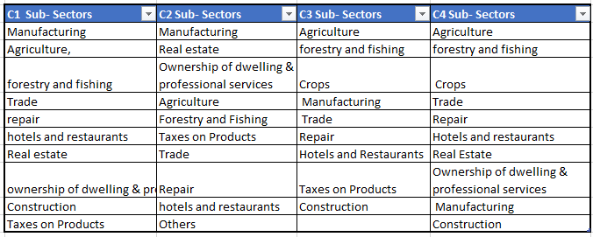

**Fig 01 – F**

Below are charts ae shown for each category and their top contributions from their sub-sectors.

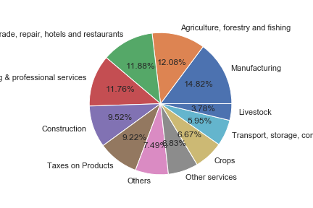

**Fig 01 Category C1 and their contributors**

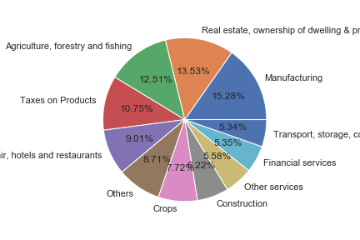

**Fig 01 Category C2 and their contributors**

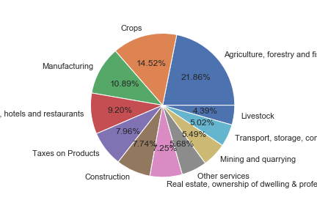

**Fig 01 Category C3 and their contributors**

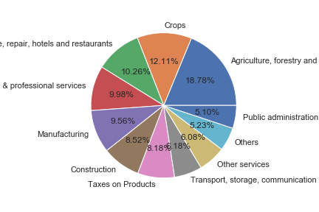

**Fig 01 Category C4 and their contributors**

**FootNotes of Part 1-A**

**Part-II: GDP and Education Drop-out Rates**

We would have noticed that one way to increase the per capita GDP is by shifting the distribution of the GDP towards the secondary and tertiary sectors, i.e the manufacturing and service industries. But these industries can thrive only when there is availability of educated, skilled labour.

We have plotted the correlation graph of Primary, Upper Primary, Secondary and GDP per capita.

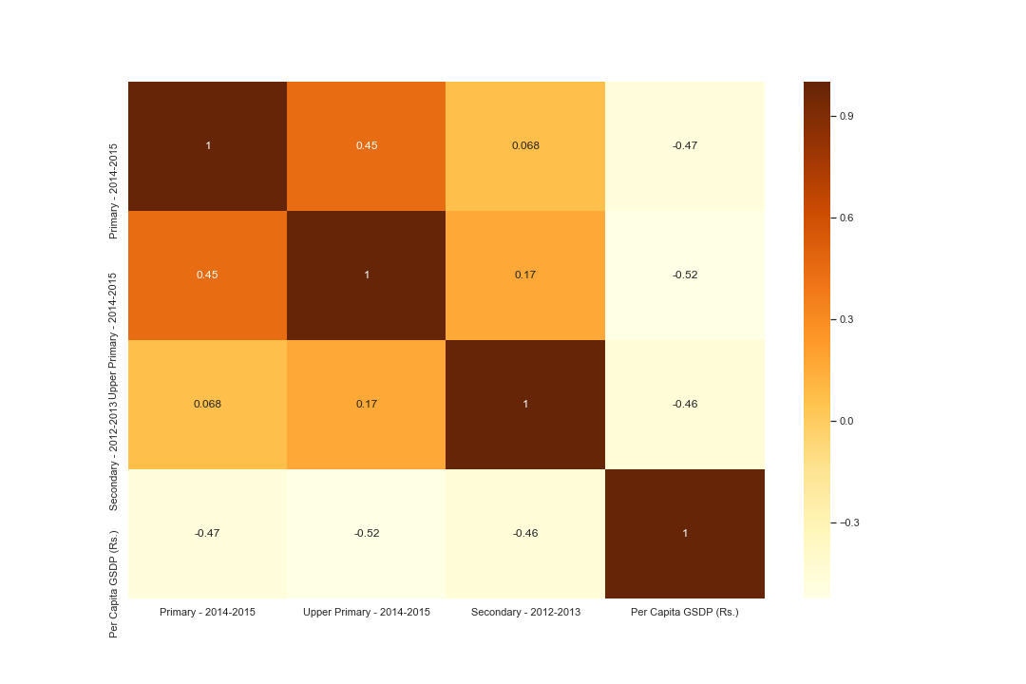

If we closely see the Corelation Graph, we can figure out that GDP per capita is negatively correlated with all the education drop outs. This is maxmum for upper primary dropouts which has -0.52 correlation.

Government should have focused on the education of upper primary then Primary and then secondary to improve the GDP per capita.